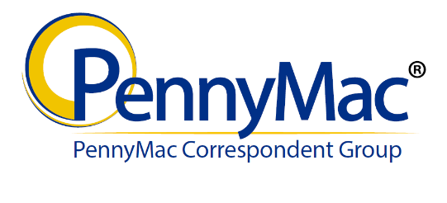

Correspondent Name___________________________________ Date___________________________

This Transmittal and Attached Documents must be delivered to:

Deutsche Bank National Trust Company
Attn: Team PennyMac/Correspondent Final Documents
1761 E. Saint Andrews Place
Santa Ana, CA 92705

Please secure documents in sequential order per transmittal. You may ship multiple transmittal bundles within one package.
PNMAC Loan Number | Correspondent Loan Number | Borrower's Last Name | Document(s) | Received

Please complete:
Tracking Number:_____________________________________________________________________________________
Please return signed transmittal form to:
Company Name:______________________________________________________________________________________
Address:____________________________________________________________________________________________
Attention:____________________________________________________________________________________________

For Document Custodian use only

Received By: ______________________________________ Date: __________________________________________
Printed Name

Signature ___________________________________________________________________________________________

Comments: __________________________________________________________________________________________

